Name: Date:

Block:

**Microscope Review Activity**

## Part A: Compound Light Microscope—Observing the letter “e” from newspaper

1. With your scissors cut out a small letter "e" from the newspaper.
2. Place it on the glass slide so the “e” is facing up.
3. Cover it with a clean cover slip. See the figure below.

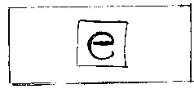

1. Using your eyedropper, place a drop of water on the edge of the cover slip where it touches the glass slide. The water should be sucked under the slide if done properly.
2. Turn on the microscope and place the slide on the stage—if you are standing behind the microscope, make sure the "e" is facing the normal reading position when you are NOT looking through the eyepiece. Turn the course focus and low power (red objective) until the "e" can be seen clearly. Draw what you see.

[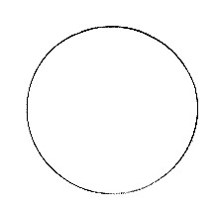](http://www.sc2000.net/~czaremba/images/circle.html)

1. Describe what the different about the “e” between what you see through the eyepiece and what you see on the stage.

__________________________________________________________________________________________________________________________________________________________________

   7. Looking through the eyepiece, move the slide to the upper right area of

the stage. (Use the terms upper, lower, right and left for #7 and 8)  
       What direction does the image move? _________________________

   8. Now, move it to the lower left side of the stage.

What direction does the image move? _________________________

   9. Locate the diaphragm under the stage. Look through the eyepiece and move the diaphragm. Record the changes in light as you do so. ________________________________________________

**Part B:** Compound Light Microscope—Focusing Elodea

1. Obtain an elodea slide. Focus the slide under low power, then medium, then high.
2. Have the teacher check your focus at high power, then draw what you see.

High Power

**Part C:** Stereo binocular Microscope—Penny

1. Obtain a penny and observe it under the stereo binocular microscope (both powers).
2. Describe what you see in complete sentences. _______________________________________________________________________________________________________________________________________________________________________________________________________________
3. Place the penny under the compound light microscope. Describe the differences in the penny between each microscope. (complete sentences)

_______________________________________________________________________________________________________________________________________________________________________________________________________________

**Clean up and return all materials!**